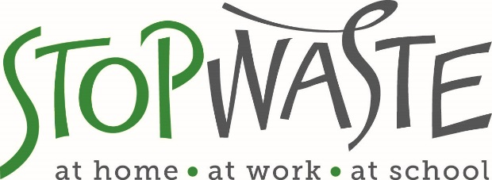

StopWaste Member Agency Staff
Scholarship Application

StopWaste is offering Member Agency staff scholarships that cover the full registration cost of the Bay-Friendly landscape training offered by ReScape California in January 2018. Member Agency staff must meet our eligibility criteria and must intend to fully complete all the graduation requirements of the course. Please see the instructions below.

TRAINING

Bay-Friendly Training & Qualification Program for Landscape Maintenance

Date: January 9, 16, 23, 30, 2018 (four consecutive Tuesdays)
Time: 8:00 AM - 3:00 PM
Location: Robert Livermore Community Center, Cresta Blanca Room
4444 East Avenue, Livermore, CA 94550

Details: rescapeca.org/event/bftraininglivermore2018

INSTRUCTIONS

This is an application for a scholarship from StopWaste for the Bay-Friendly training listed above. To qualify for the scholarship, you must:

- Complete page 2 of this application and email a scan or photo of it to Jennifer West at StopWaste, jwest@stopwaste.org; AND
- Use the promo code SWScholarship2018 to register for the class directly with ReScape California at rescapeca.org/event/bftraininglivermore2018.

You must both register for the class directly with ReScape using the StopWaste promo code and complete this application form. Failure to do both may result in not getting into the class or not receiving a scholarship from StopWaste.

2018 BAY-FRIENDLY SCHOLARSHIP APPLICATION

Please mark with an X all that are applicable (all three are required).
[ ] I am fluent in written and spoken English. (Required)
[ ] I have 2 years of experience in at least one of these areas; landscape design, construction, maintenance, management or planning. (Required)
[ ] I have not taken the Bay-Friendly Maintenance Training before. (Required)

Please mark with an X all that are applicable (at least one must be applicable):
[ ] I have experience maintaining civic landscapes.
[ ] I supervise employees and/or contractors who maintain civic landscapes.
[ ] I am a city planner.
[ ] I am a landscape architect.
[ ] I am responsible for capital improvement projects in my agency that include landscapes.

Please complete this section:
Name:
Title:
City/Agency:
Work Address:
Phone Number:
Email:

The Bay-Friendly Maintenance Training graduation requirements are:
- Attend all four full-day classes.
- Complete the take-home test packet and turn it in on the last day of class. (To pass, you must score 75% or higher. The test is open book.)
- Participate fully in the practicum/hands-on field day on the last day.

The undersigned applicant and supervisor agree that the applicant meets the qualification criteria for the course and that the applicant fully intends to complete all the graduation requirements for the course. We also know that failing to complete the course can impact future scholarship funds for our agency from StopWaste. Failure rates of greater than 50% from one city or agency will result in scholarships subsidies being lowered for future applicants.

Signature of Applicant: ________________________________ Date: _________________

Signature of Applicant’s Supervisor/Manager: _____________________________________

Print Name of Supervisor/Manager & Job Title: ____________________________________

Date: _________________

