**Building Resources photos – provided by Ed Dunn**Note: These images were not shown during the meeting due to technical difficulties.

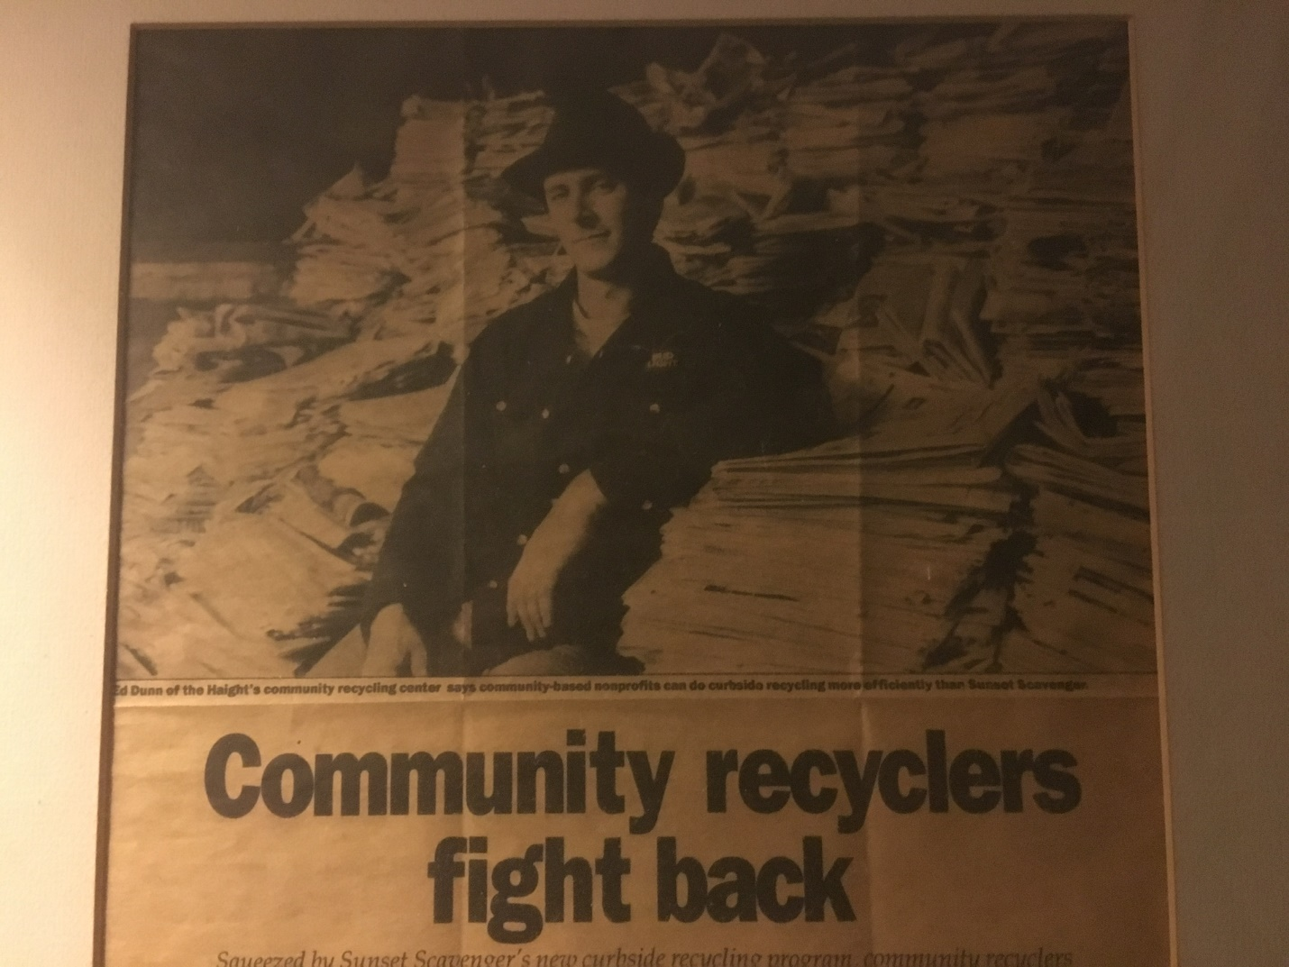  
  
[Building Resources](https://buildingresources.wordpress.com/) is a project of San Francisco Community Recyclers. SFCR was founded in 1980 to provide administrative and logistical support to San Francisco’s network of Drop-off Recycling Centers which mushroomed after Earth Day 1970.  
  


SFCR doesn’t operate recycling centers any more but is still an advocate for the State Bottle Bill. Executive Director Ed Dunn was interviewed by ABC 7’s Michael Finney (pictured above, posing with Piper Dunn ) in March of this year in the wake of a new report on the Bottle Bill, put out by [ConsumerWatchdog.Org](http://ConsumerWatchdog.Org).

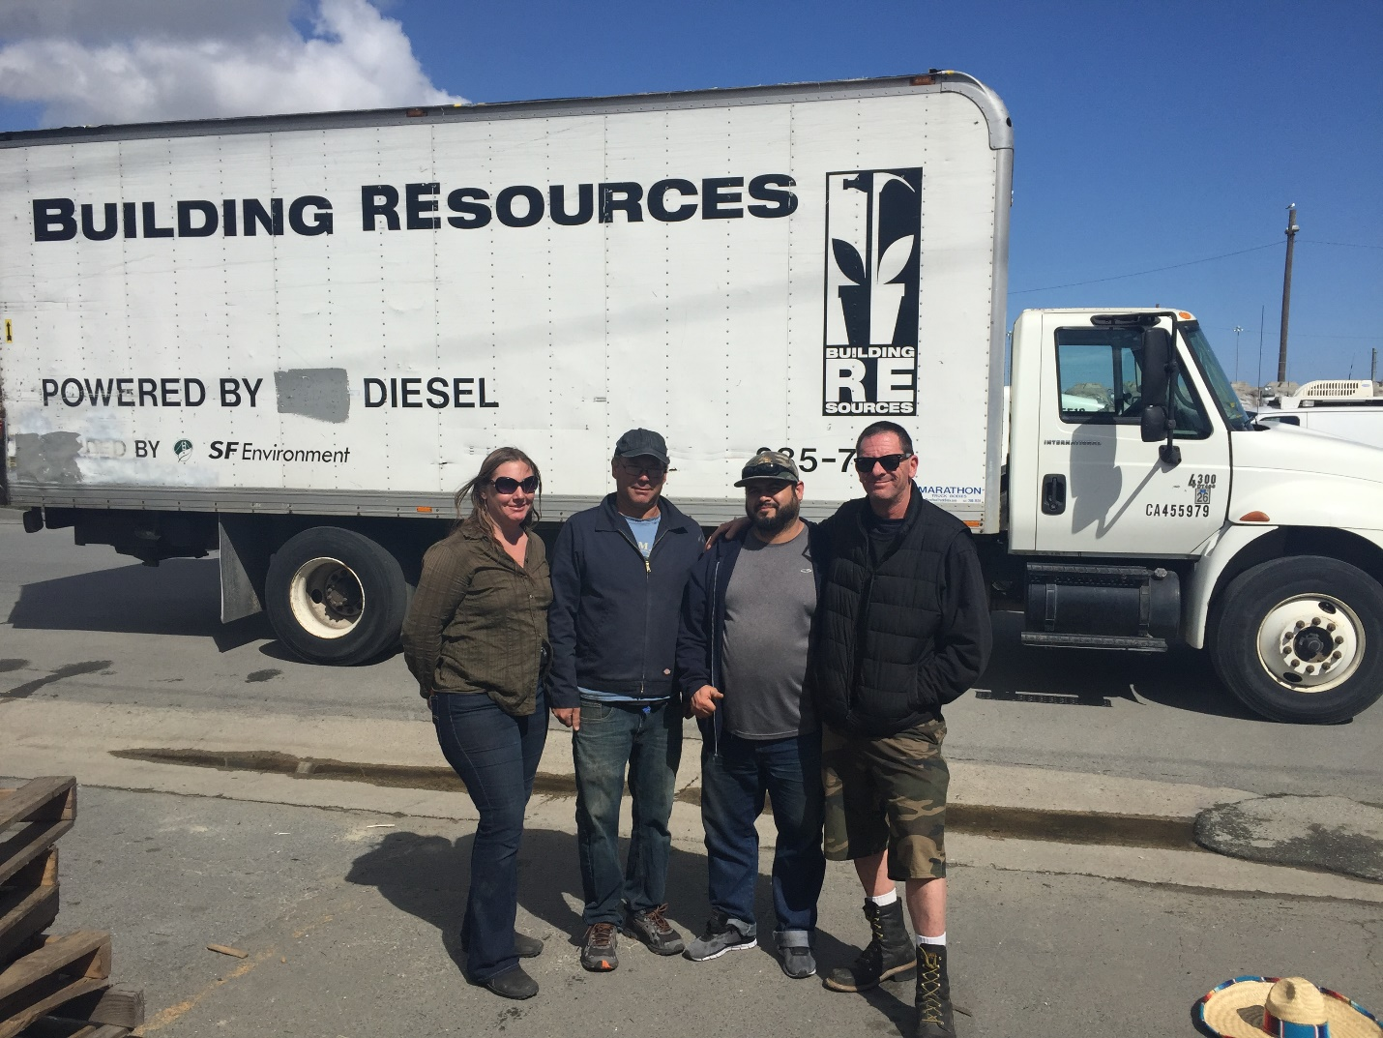

Some of the Building Resources crew. Those four crew members have a combined 109 years of service with the organization.



Decon lumber coming in.

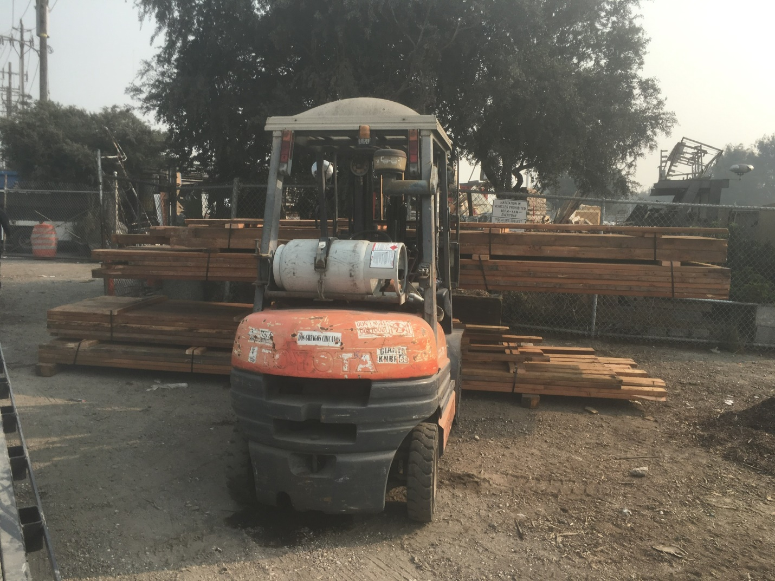

Forklift been on the job for 22 years.

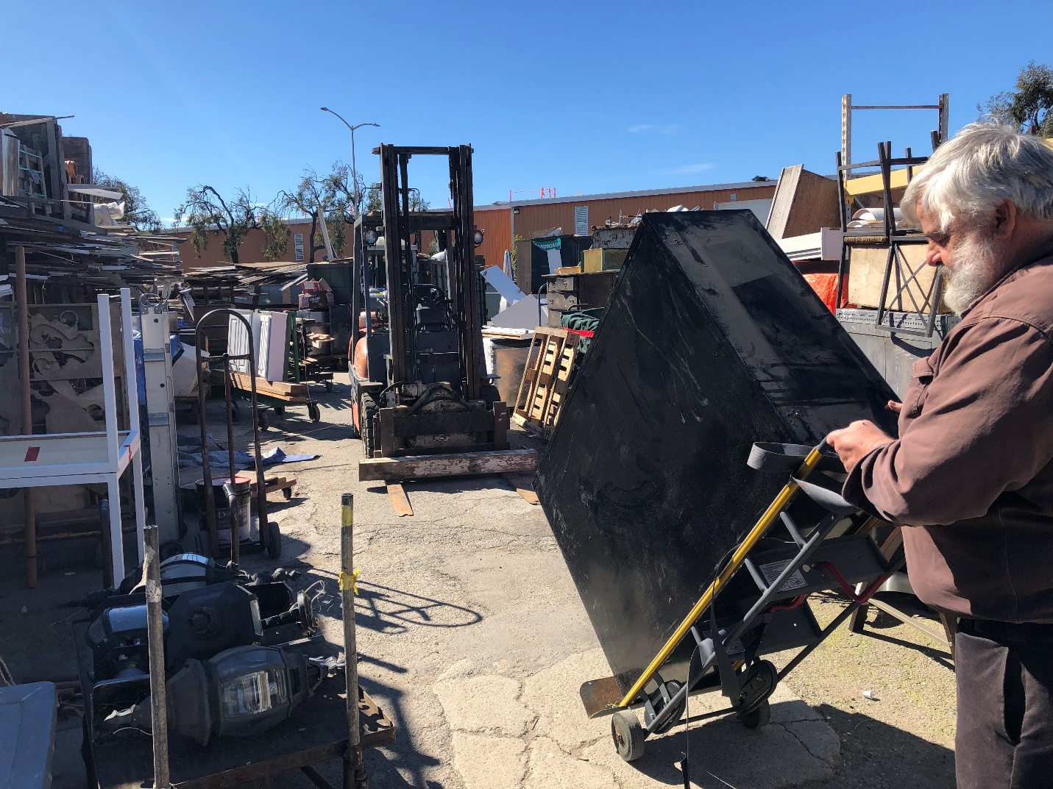

Action photo of Dave Williamson, the visionary who first suggested to SFCR that reused building materials should be pursued.



Building Resources also has an art gallery called the ReClaimed Room. Those pieces above were created with a zap of high voltage electricity powered by a hacked microwave oven.



SF history comes through. Sofa from a hotel downtown. Which one?

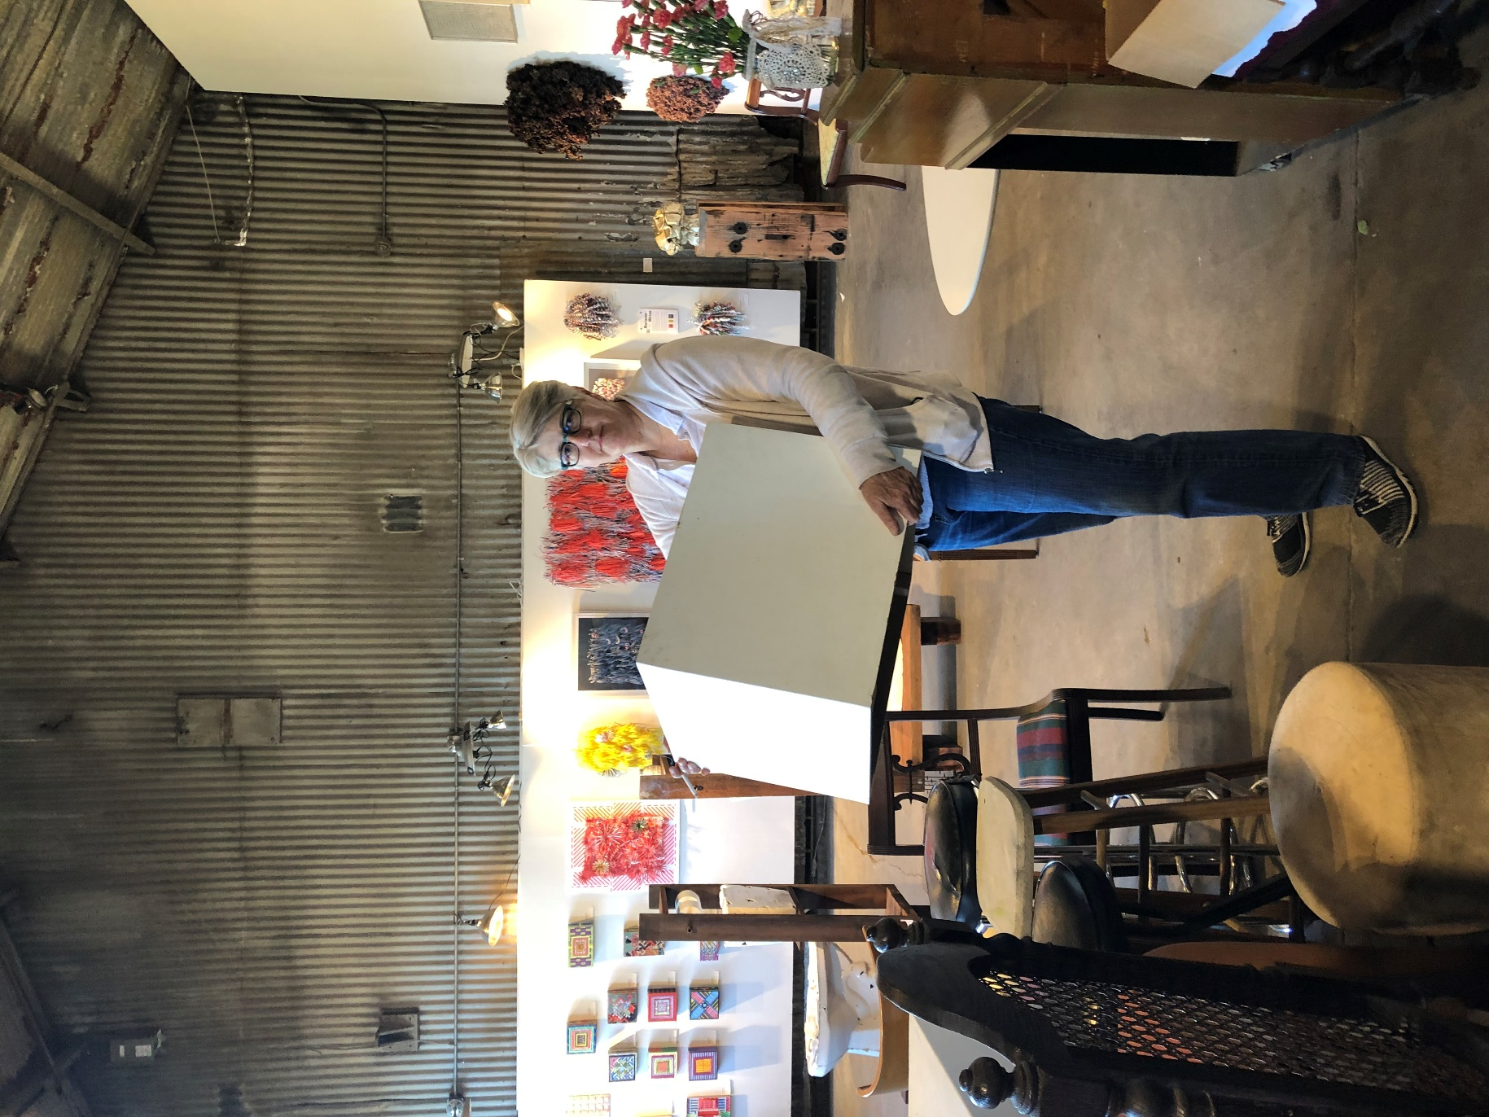

Another shot of the art gallery.